

**ASSUMPTION UNIVERSITY**

**FACULTY OF ENGINEERING**

**BG1221 Computer Programming**

**Movie Ticket Booking System**

Name : Nyi Nyi Myo Zin Htet ( 5918154)

Asif Rashid (5918186)

Section : 643

Date : 28.11.2016

**Introduction**

We are presenting an easy C program which can make your movie experience in theatre much easy. Our program can help anyone book or buy tickets in a theatre. Anybody above the age of 10 can use this program. You do not have to be a rocket scientist to operate this program.

**Project Description**

This program required the use to the functions like:

1. do-while function
2. switch function
3. goto function
4. if-else function

**Instruction Manual**

To book your favorite movie successfully you have to follow the following steps:

Step I: The program will show the names of the movies playing in the theatre.

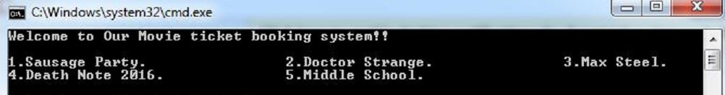

Step II: Enter the number assigned to your preferred movie.

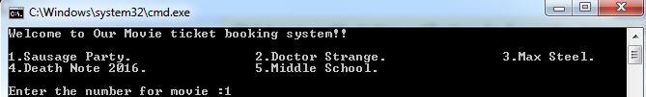

Step III: Then enter the number assigned to the day you prefer to watch the movie.

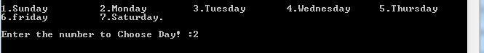

Step IV: Then enter the number for the given time to choose the time for the movie.

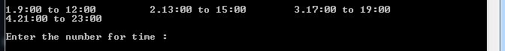

Step V: Then Enter the number of the seat type to choose the type of seat you want. (Enter 1 to book a VIP seat and 2 to book normal seat)

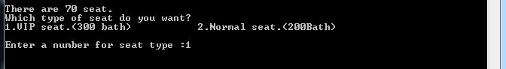

Step VI: Enter the number of seats you want to book.

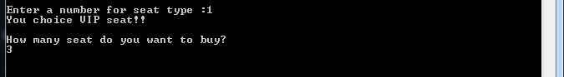

Step VII: Enter 1 if you want to book again.

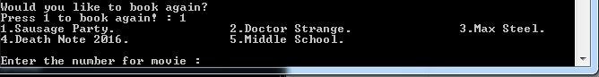

** 20% TICKET DISCOUNT ON WEDNESDAY FOR ALL THE MOVIES OF SHOWTIME BETWEEN 17:00 AND 23:00**

**Result**

Watching movie in a cinema theatre will never been so much easier than this.

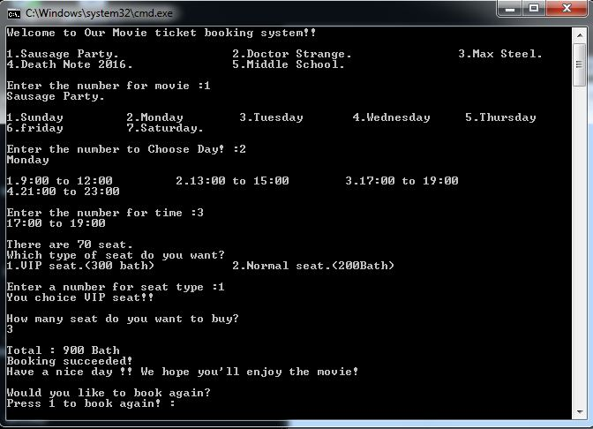

**Conclusion**

Now you can enjoy movies in theatre in a much easy and sophisticated

way.



**FLOW CHART**